**INFO 5505 – APPLIED MACHINE LEARNING FOR DATA SCIETISTS**

**Assignment - 6**

**Image Classification**

**Data:**

The data contains around 25k images of size 150*150 distributed under 6 categories.

1. Buildings
2. Forest
3. Mountains
4. Glacier
5. Sea
6. Street

The data is given 3 zip files seg_train.zip, seg_test.zip and seg_pred.zip. These zip files contain Test, Train and Prediction in respective folders.

**Task for this assignment:**

Developing a CNN model that can classify the images and into 6 categories, validating the model with 10-fold cross validation, developing another model with Transfer learning process an comparing these two models.

1. **Importing Necessary packages:**

Below python packages are used in this assignment

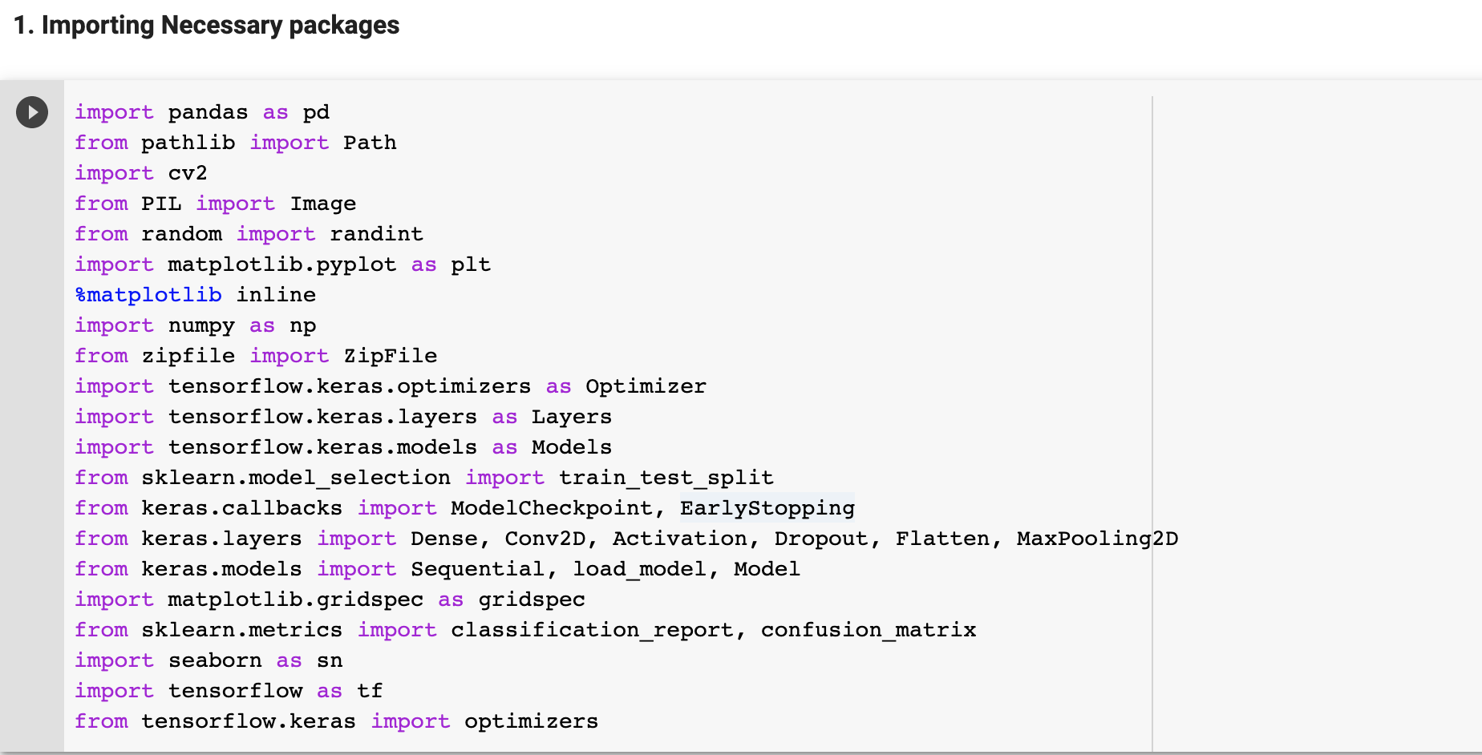

1. **Defined functions:**

I have defined functions that are used in the pipeline. Each function and its usage is commented in the code.

* 1. Data Functions

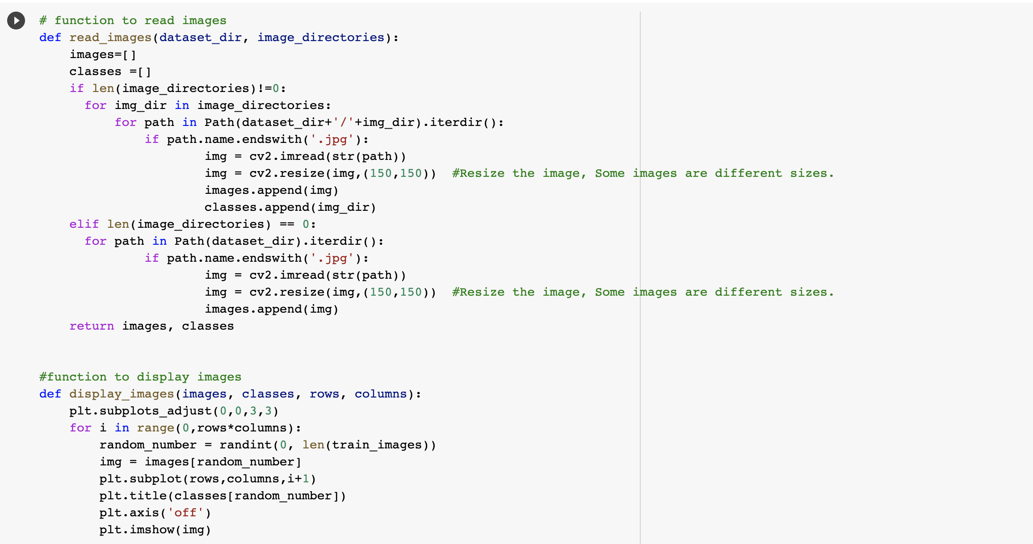

* 1. Util functions

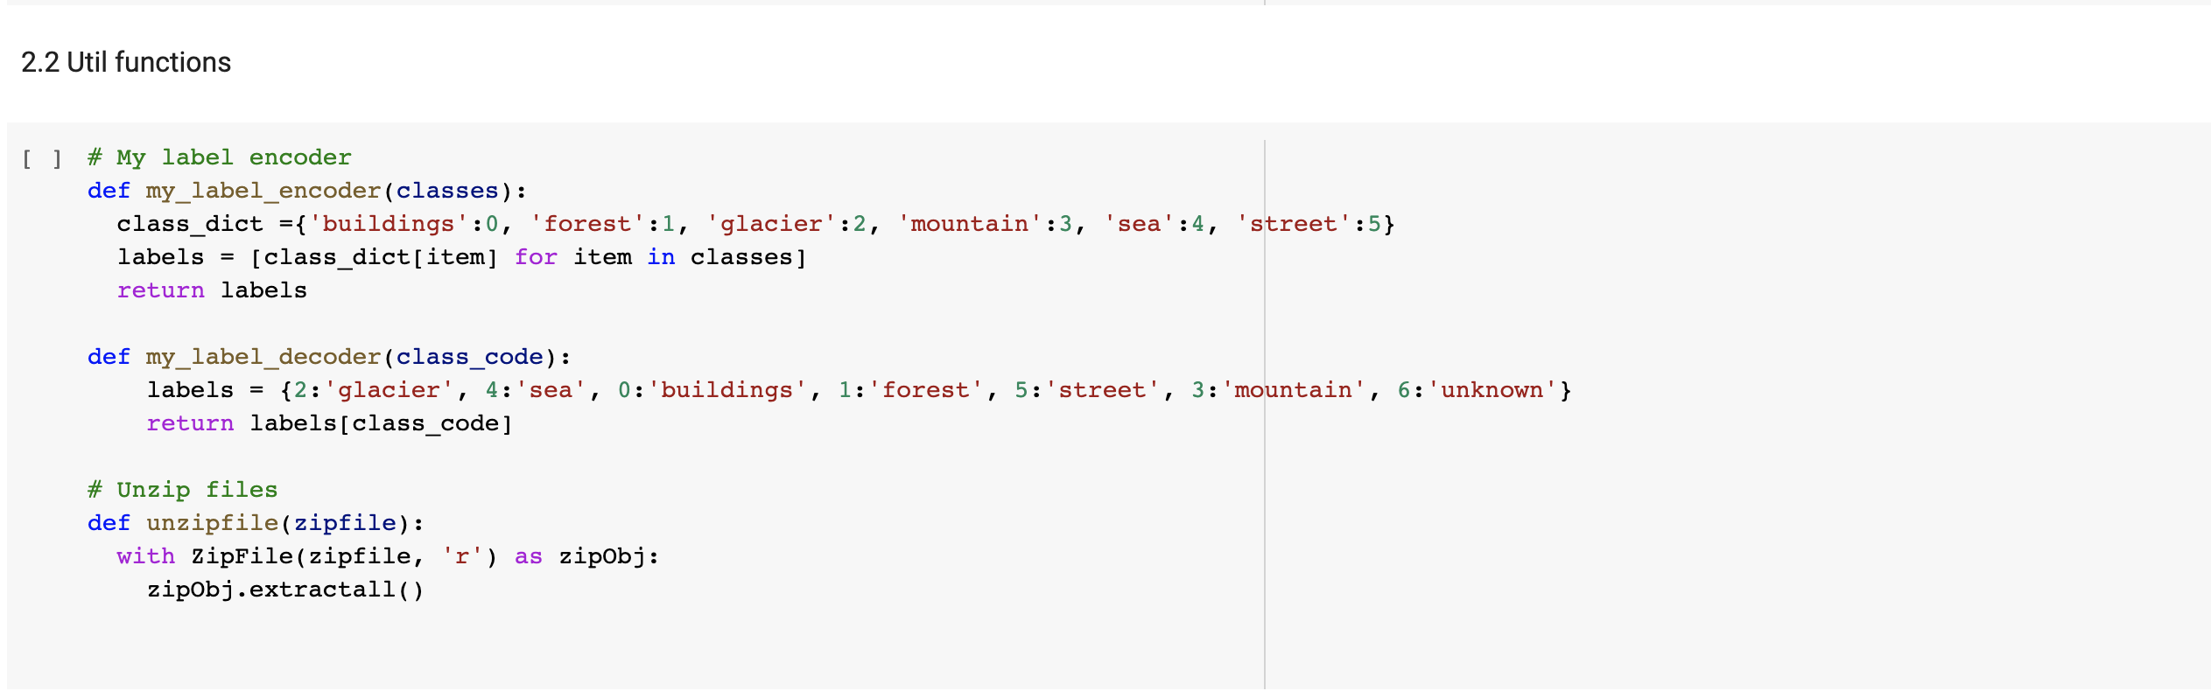

* 1. Model functions

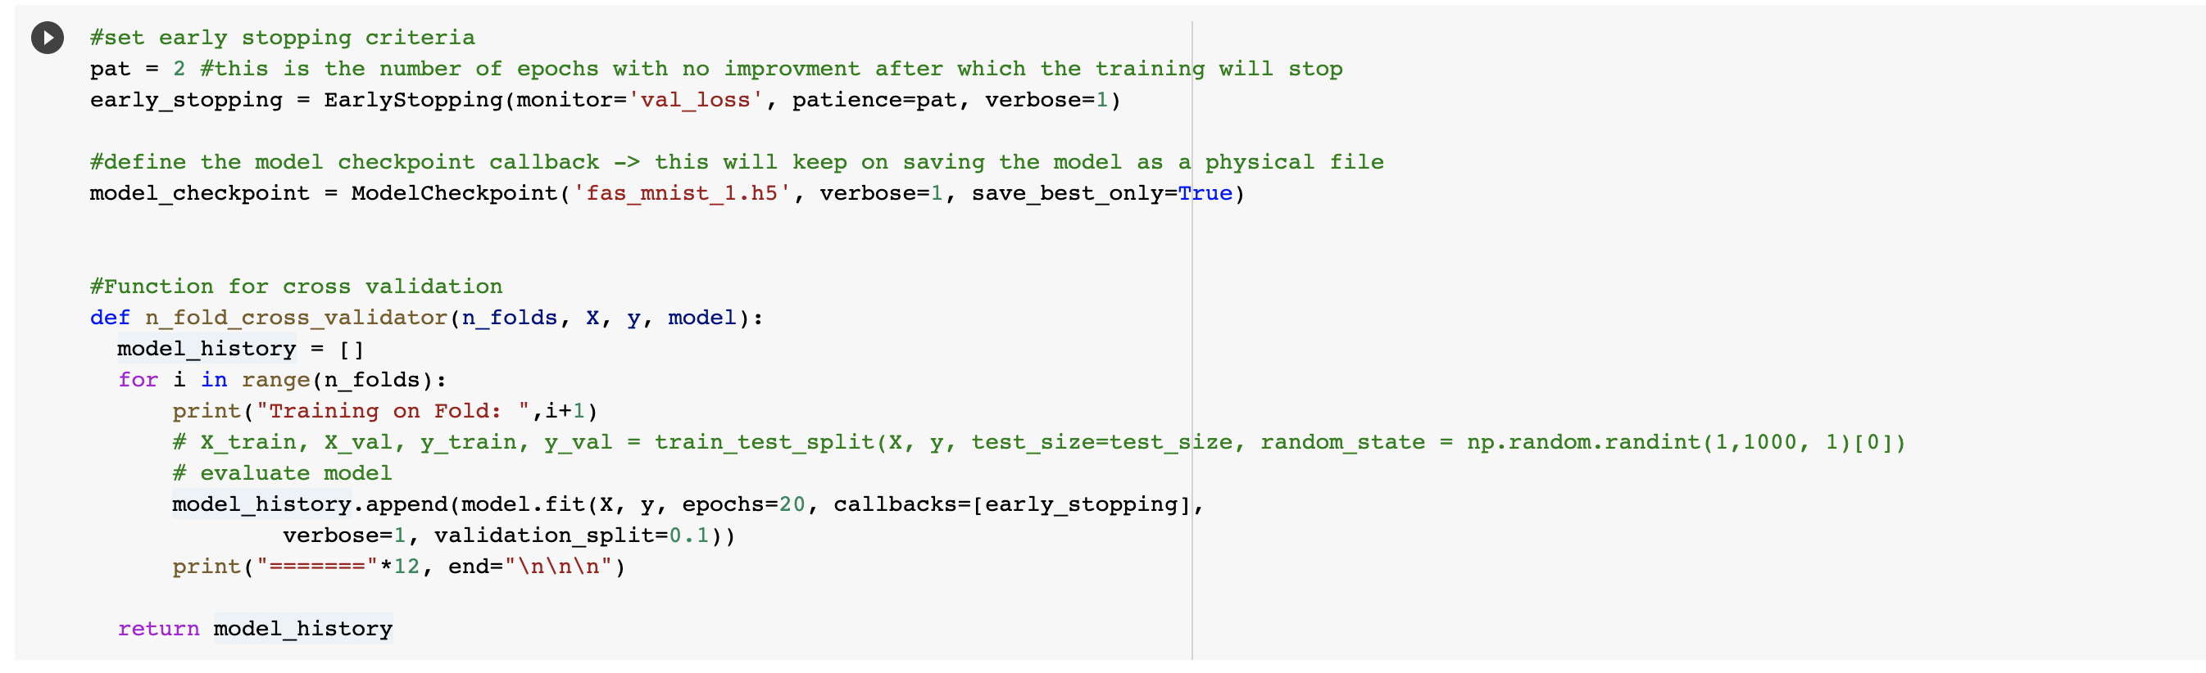

1. **Reading and visualization of train images**

In this section below tasks are performed

* Reading the images and its categories from training data set
* Resizing the images to (150*150)
* Converting the images into NumPy array for model development
* Visualizing the 25 random images with their categories

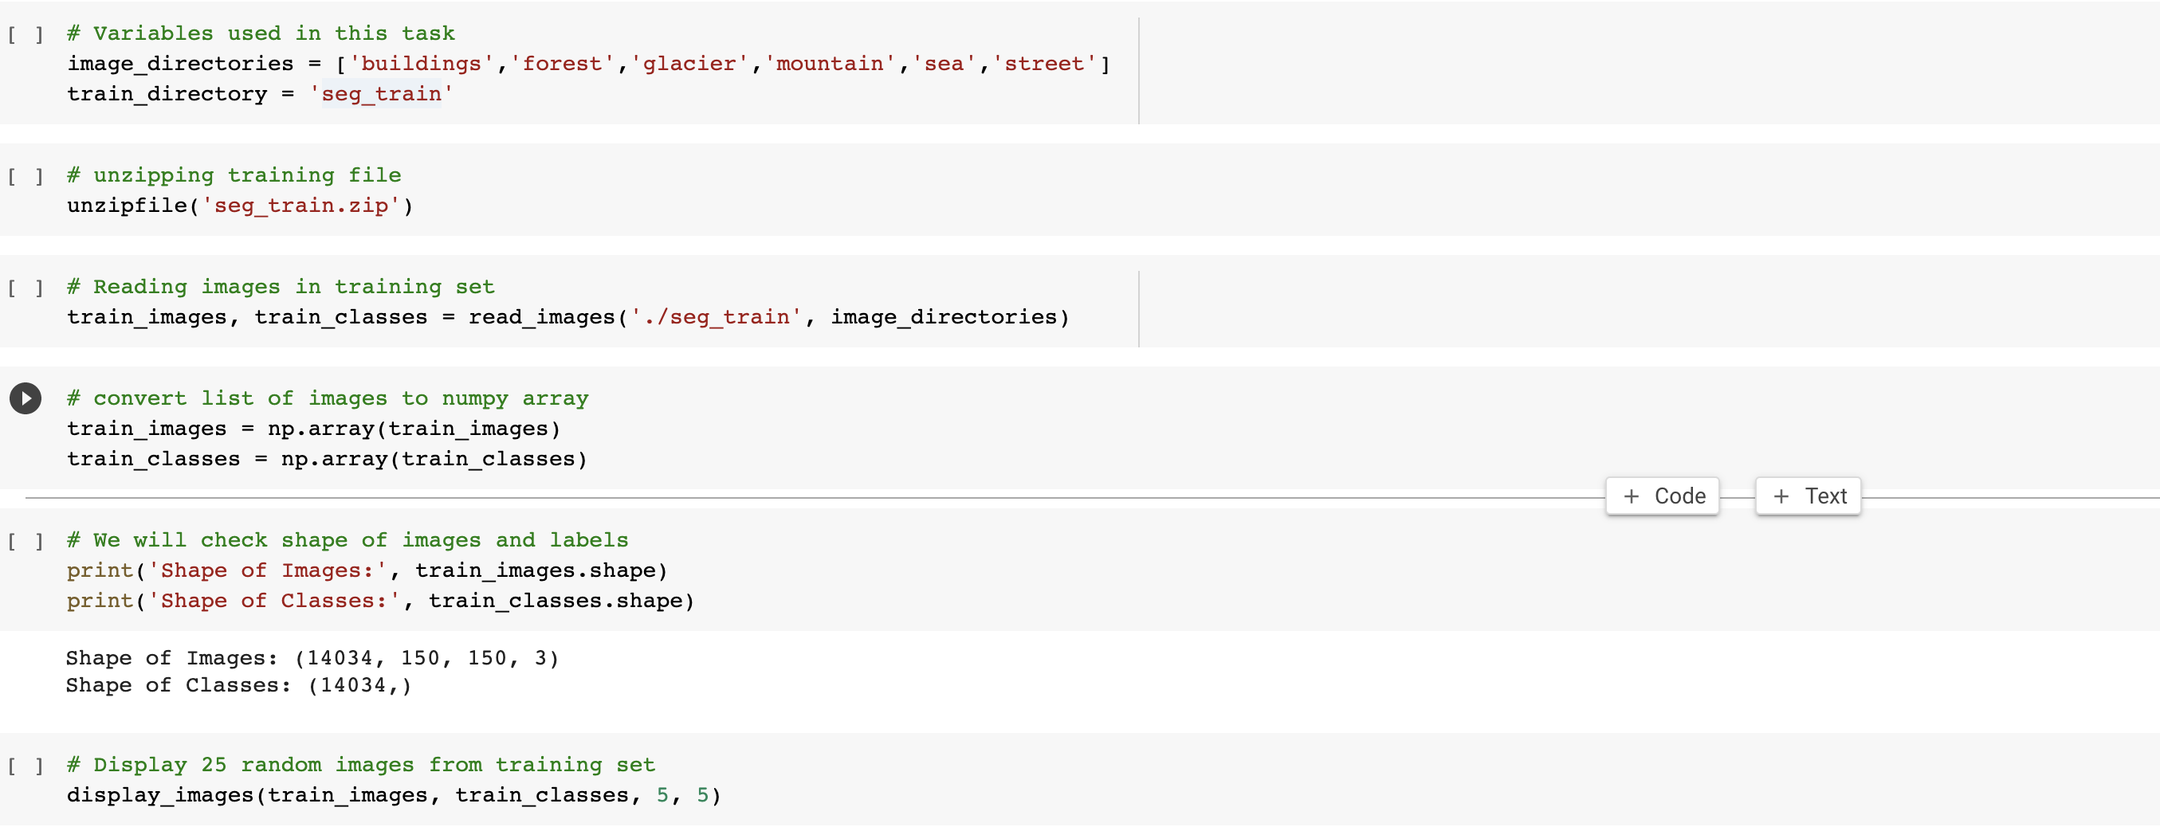

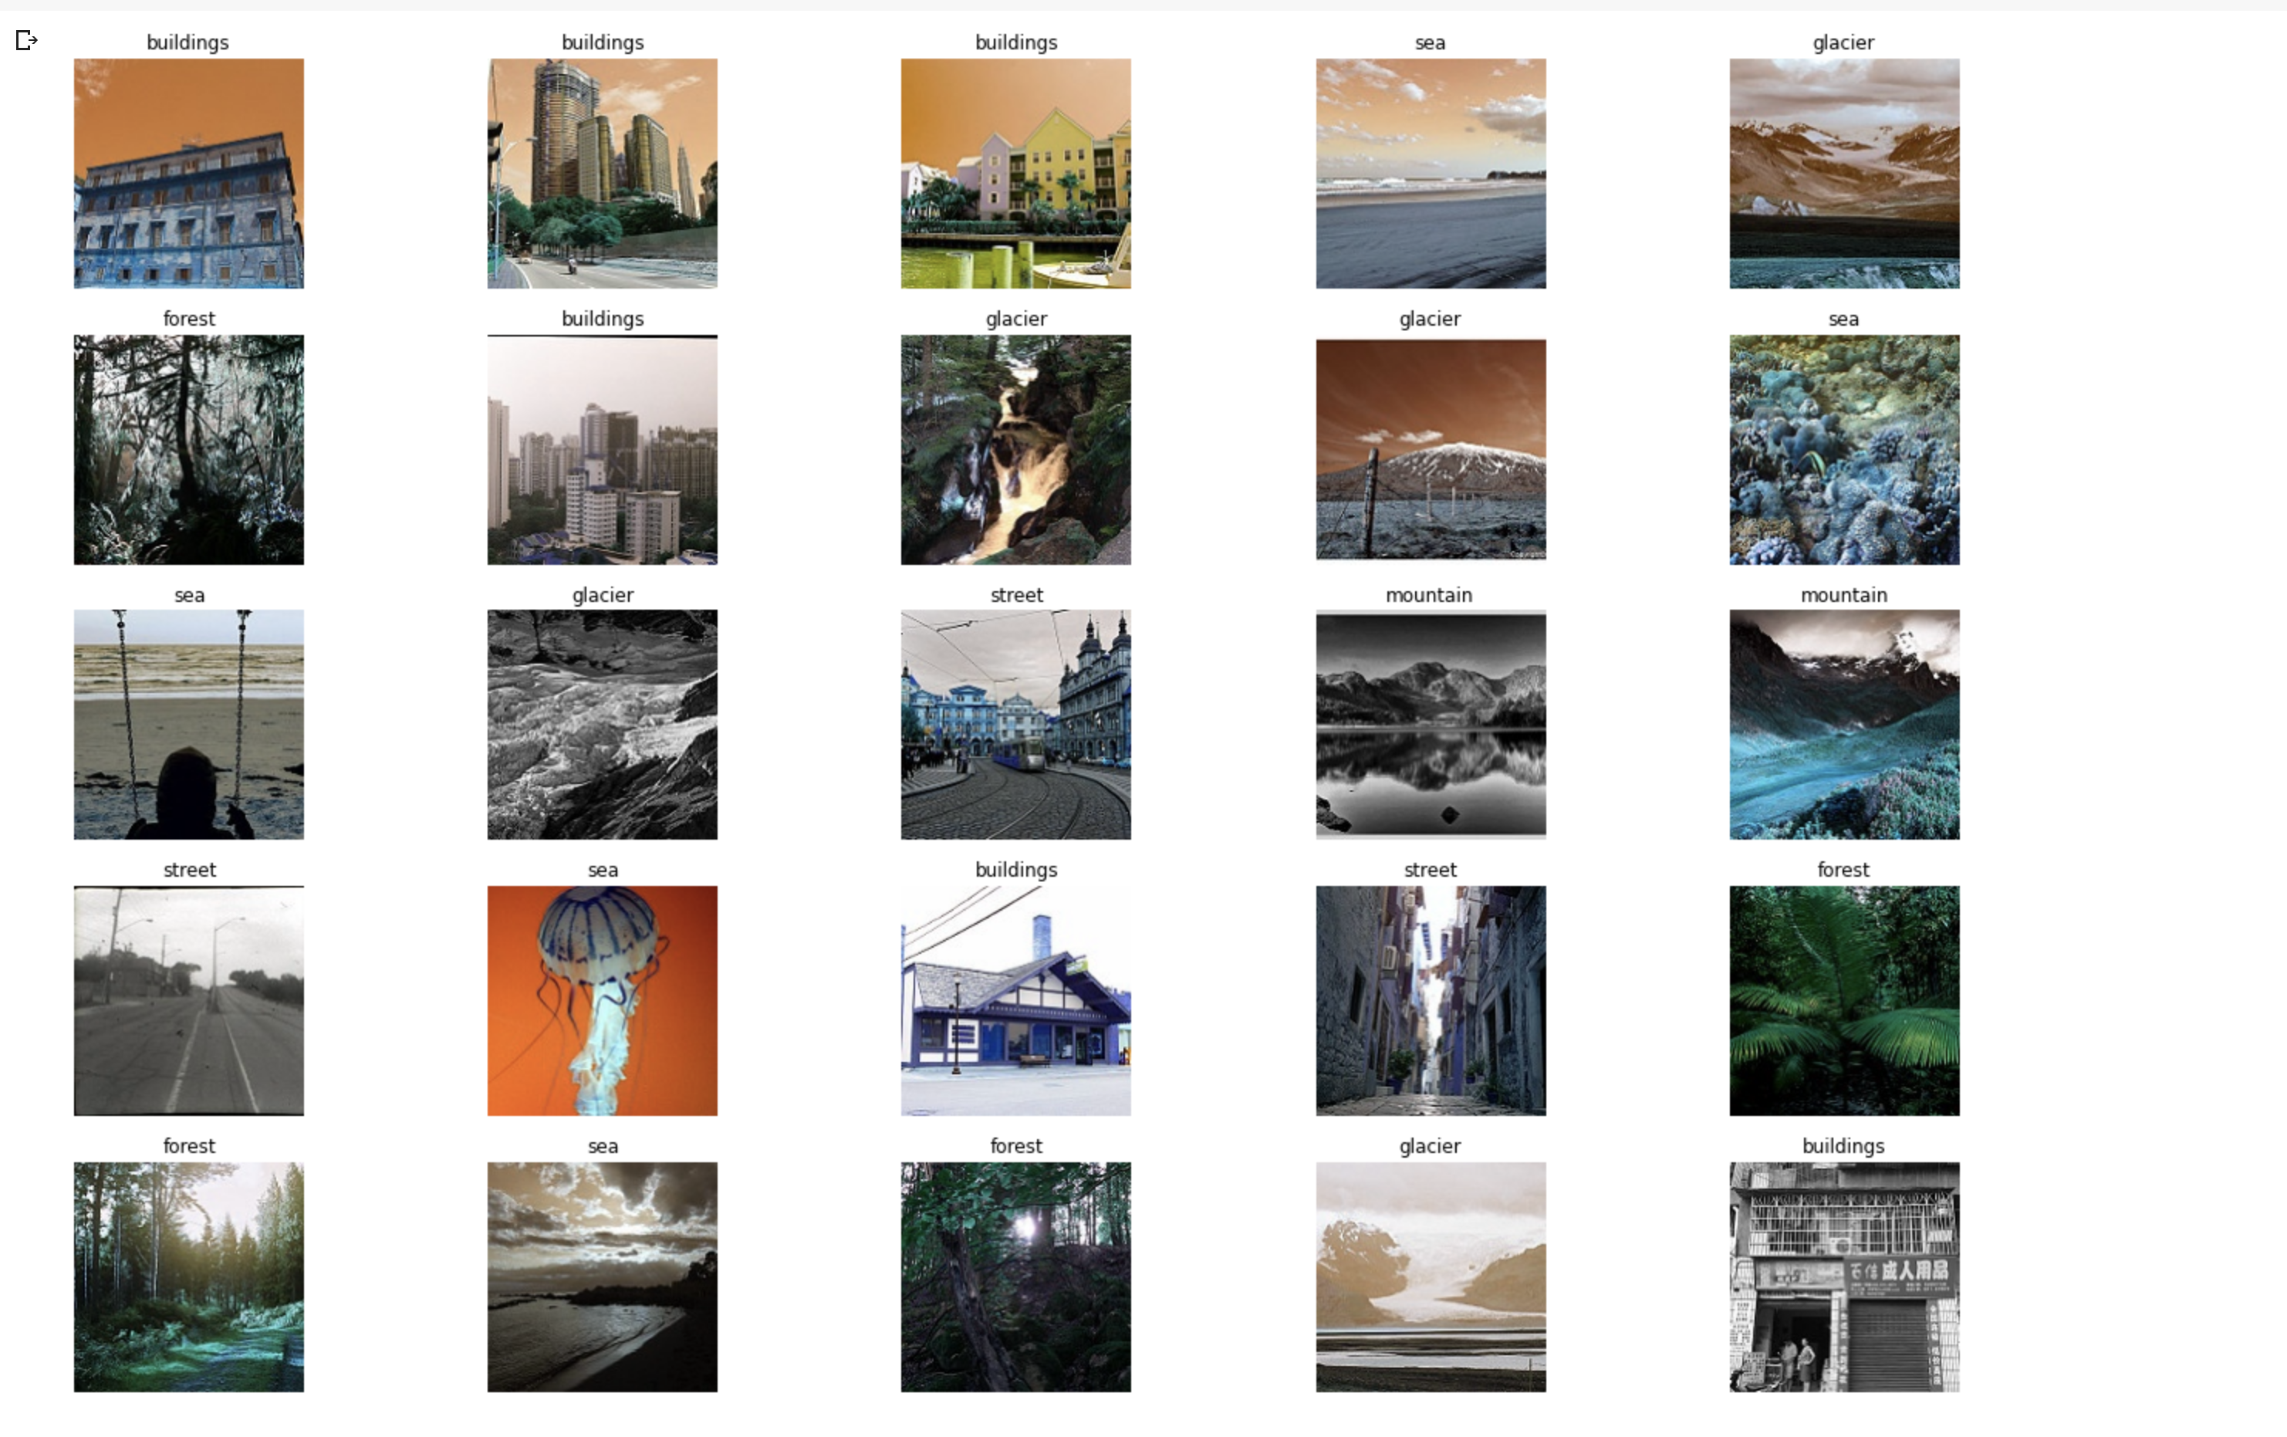

1. **Developing a CNN model**

A sequential CNN model is developed which can classify the images into 6 categories. I have used below mentioned activation functions, filters and pooling functions in the model development.

* 1. **Activation function (Relu):** The activation function is the nonlinear transformation that we do over the input signal. This transformed output is then sent to the next layer of neurons as input.

I have used “**ReLU**” (**Rectified Linear Unit**) as my activation function. One of the greatest advantages ReLU has over other activation functions is that it does not activate all neurons at the same time. This makes it very computational efficient as few neurons are activated per time. It does not saturate at the positive region. In practice, ReLU converges six times faster than tanh and sigmoid activation functions.

* 1. **Pooling function (MaxPool2D):** I have used MaxPool2d function as my pooling function. Down samples the input representation by taking the maximum value over the window defined by pool size for each dimension along the feature’s axis. The window is shifted by strides in each dimension. The resulting output when using "valid" padding option has a shape (number of rows or columns) of: output_shape = (input_shape - pool_size + 1) / strides)

1. **Filter function (Conv2D):** The most common type of convolution that is used is the 2D convolution layer, and is usually abbreviated as conv2D. A filter or a kernel in a conv2D layer has a height and a width. They are generally smaller than the input image and so we move them across the whole image. The area where the filter is on the image is called the receptive field.

Conv2D filters extend through the three channels in an image (Red, Green, and Blue). The filters may be different for each channel too. After the convolutions are performed individually for each channel, they are added up to get the final convoluted image. The output of a filter after a convolution operation is called a feature map.

**Code:**

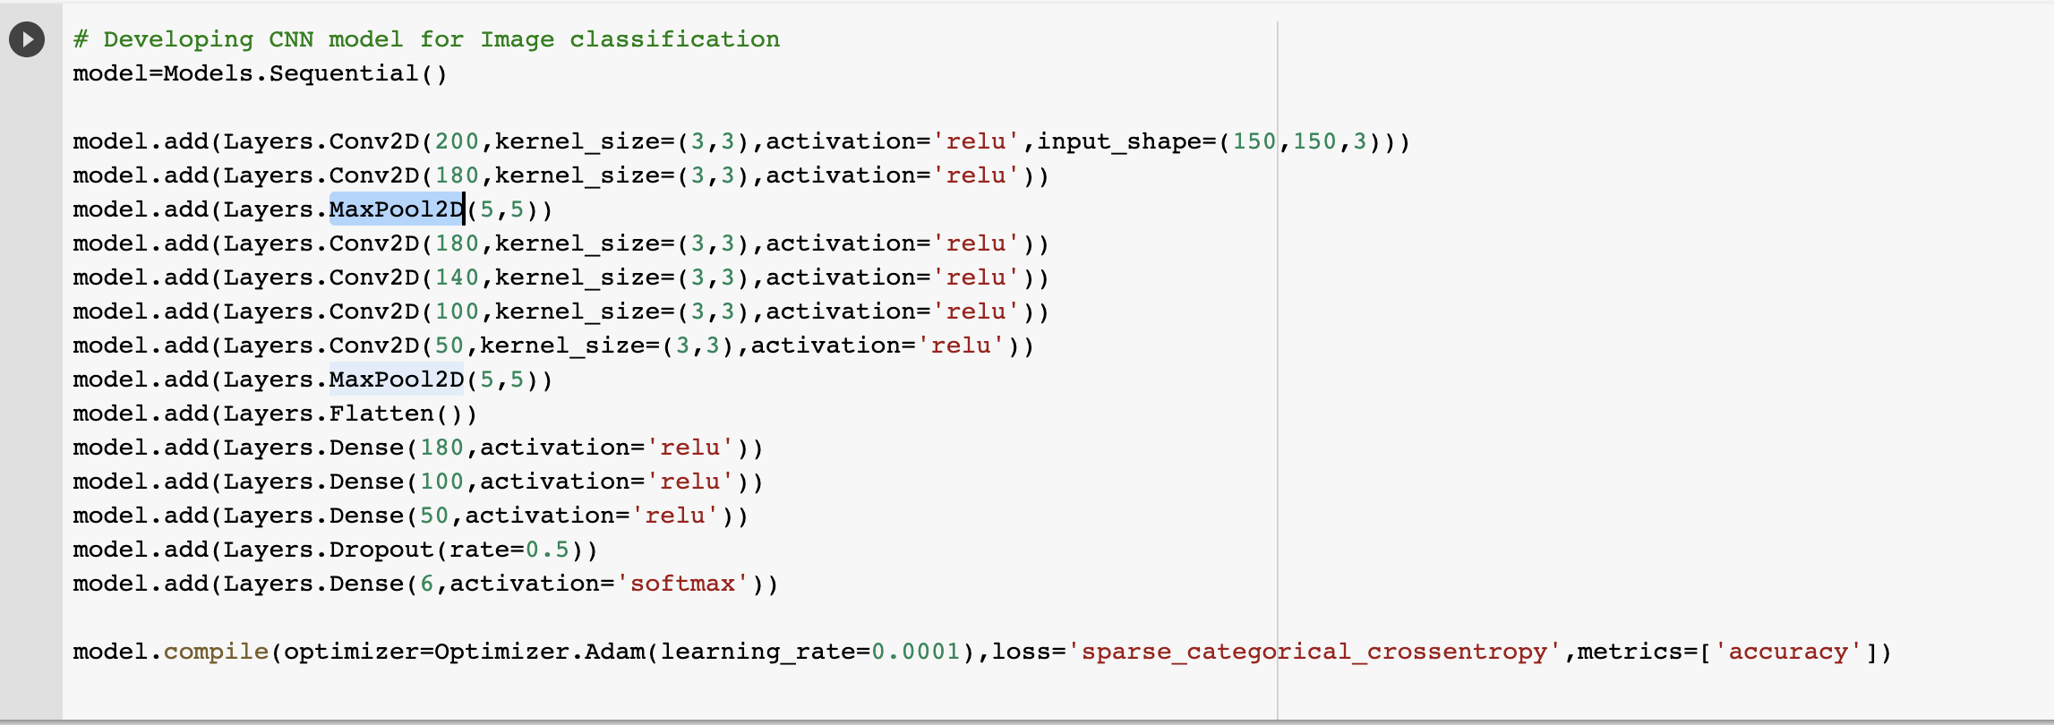

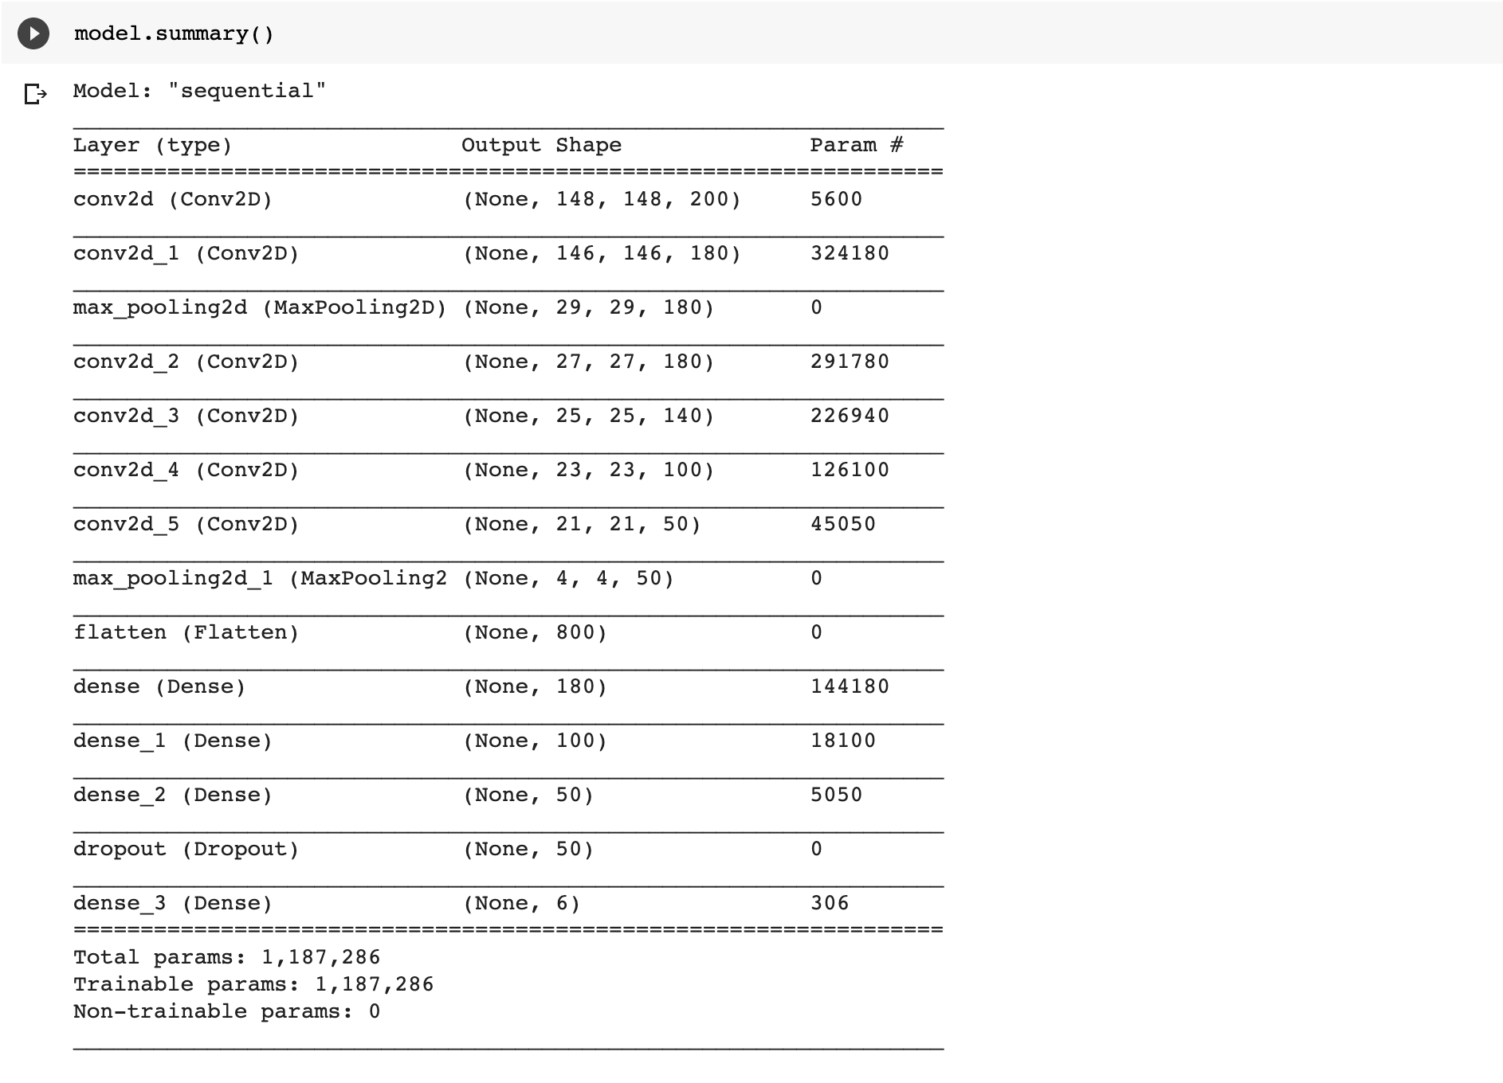

1. **Validating CNN model**

The model is validated using two methods

* 10-fold cross validation
* Validation with test data

1. **10-fold cross validation:**

In 10-fold cross validation the CNN model is trained in 10 layers. In each layer the model accuracy and validation accuracy are recorded and stored in a list. The train data is split into train and validation set. The validation data is 10% of the train data.

In each layer the training will be stopped after 2 continuous epochs where the validation loss is not improved. Finally, the results of cross validation are visualized.

Below are the functions used in cross validation and its results.

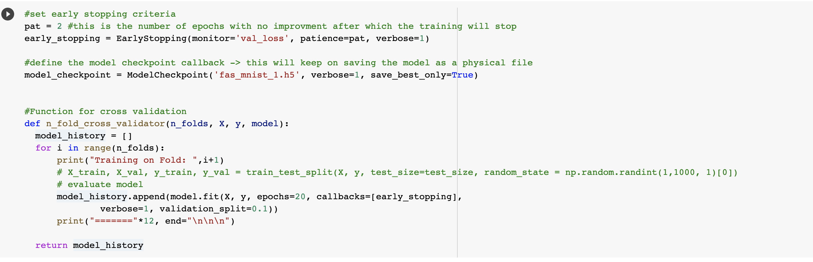

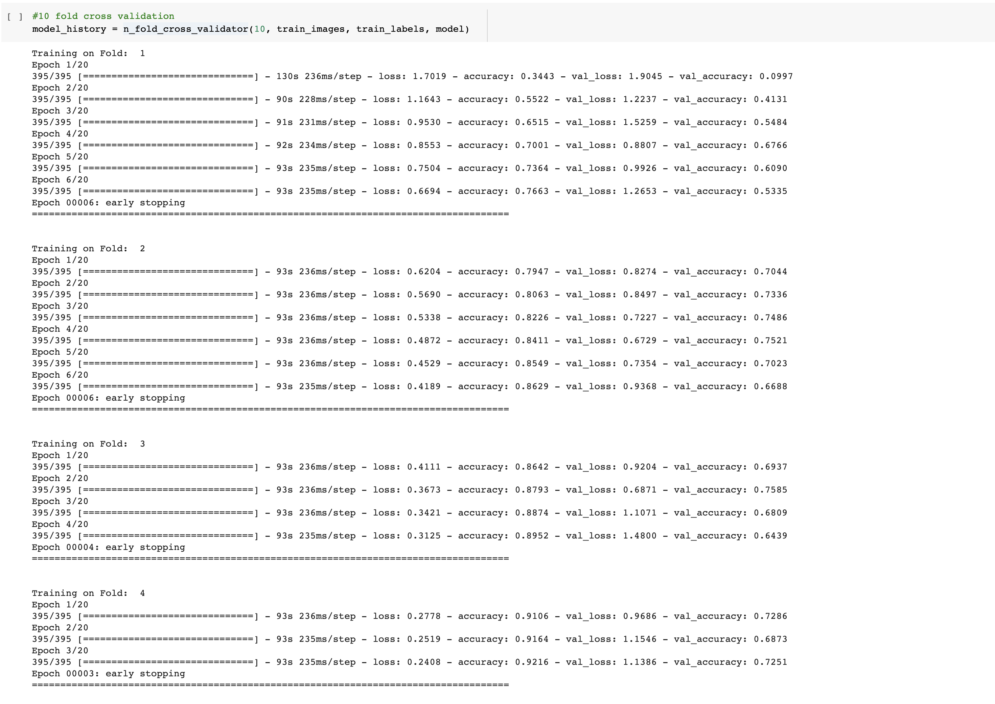

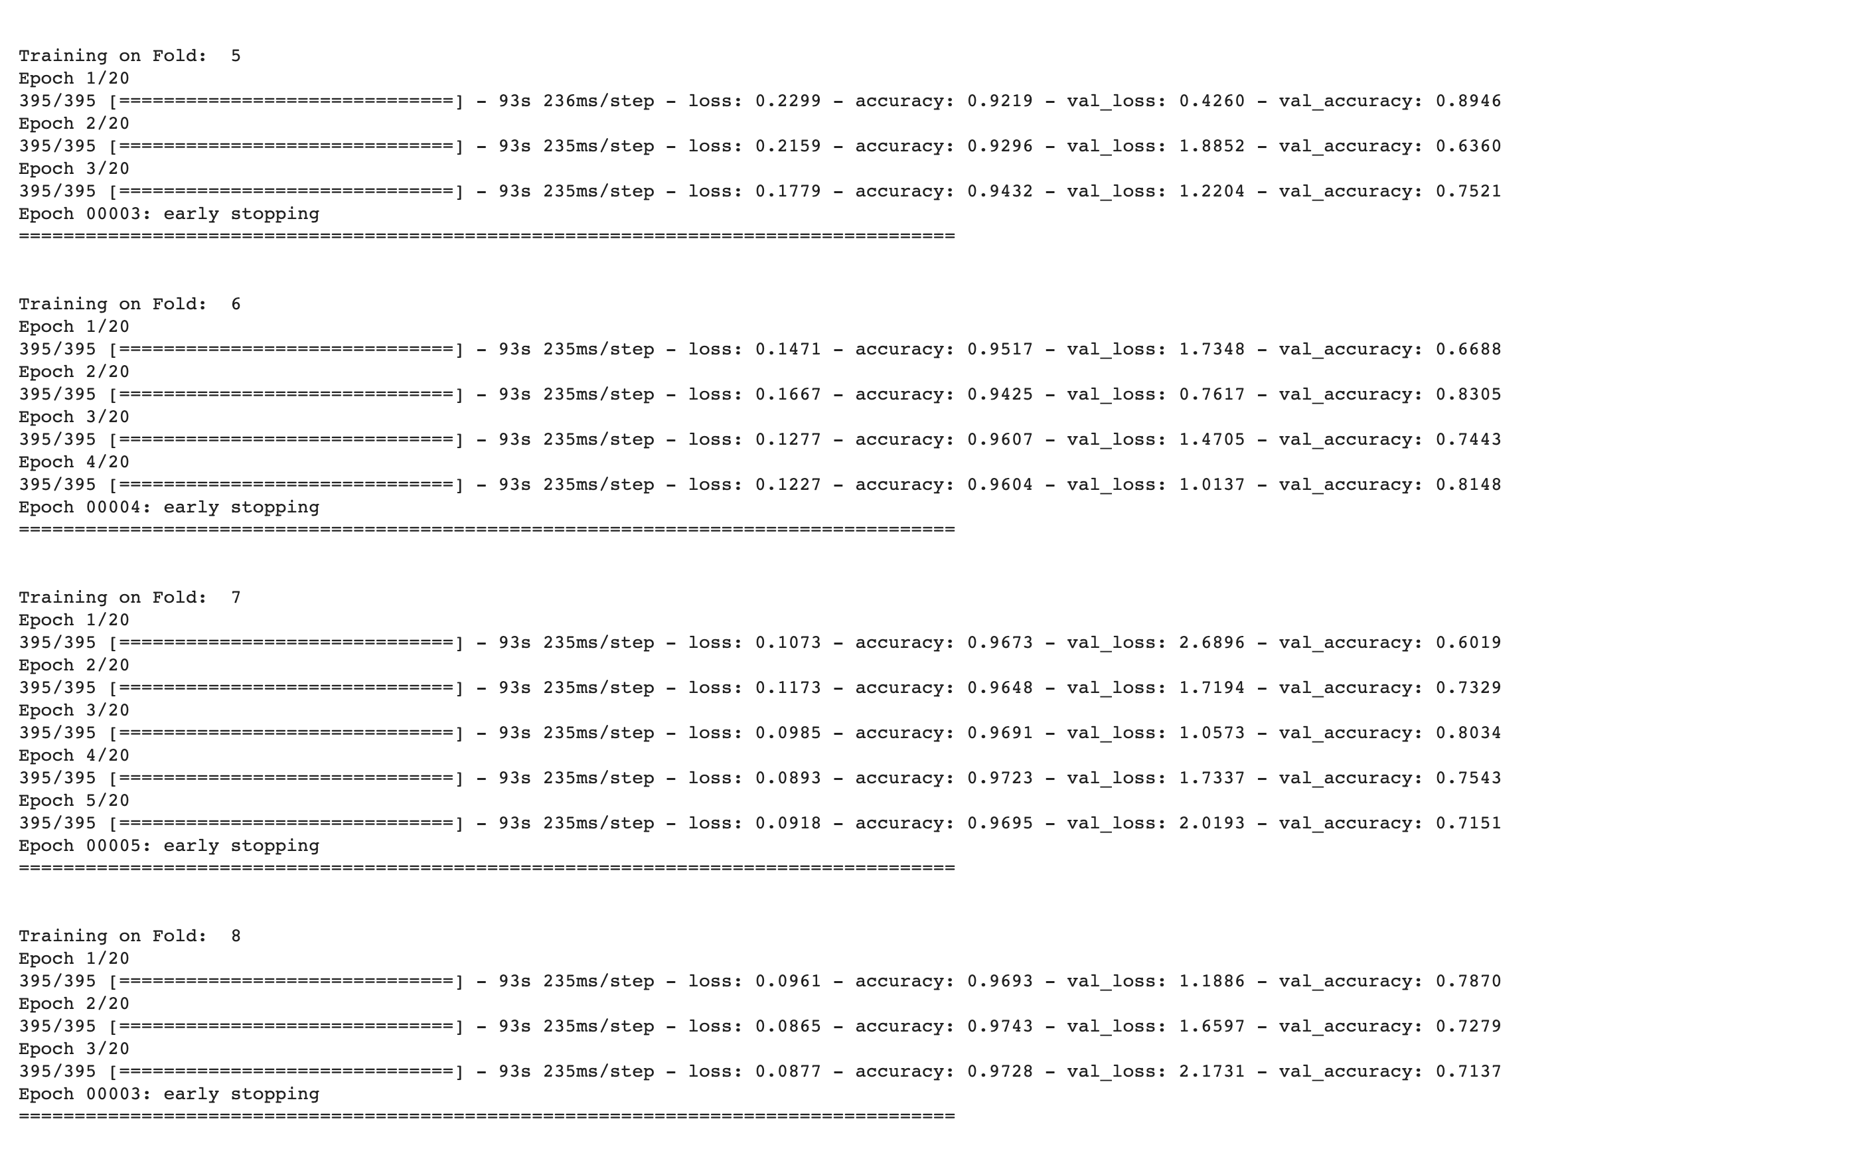

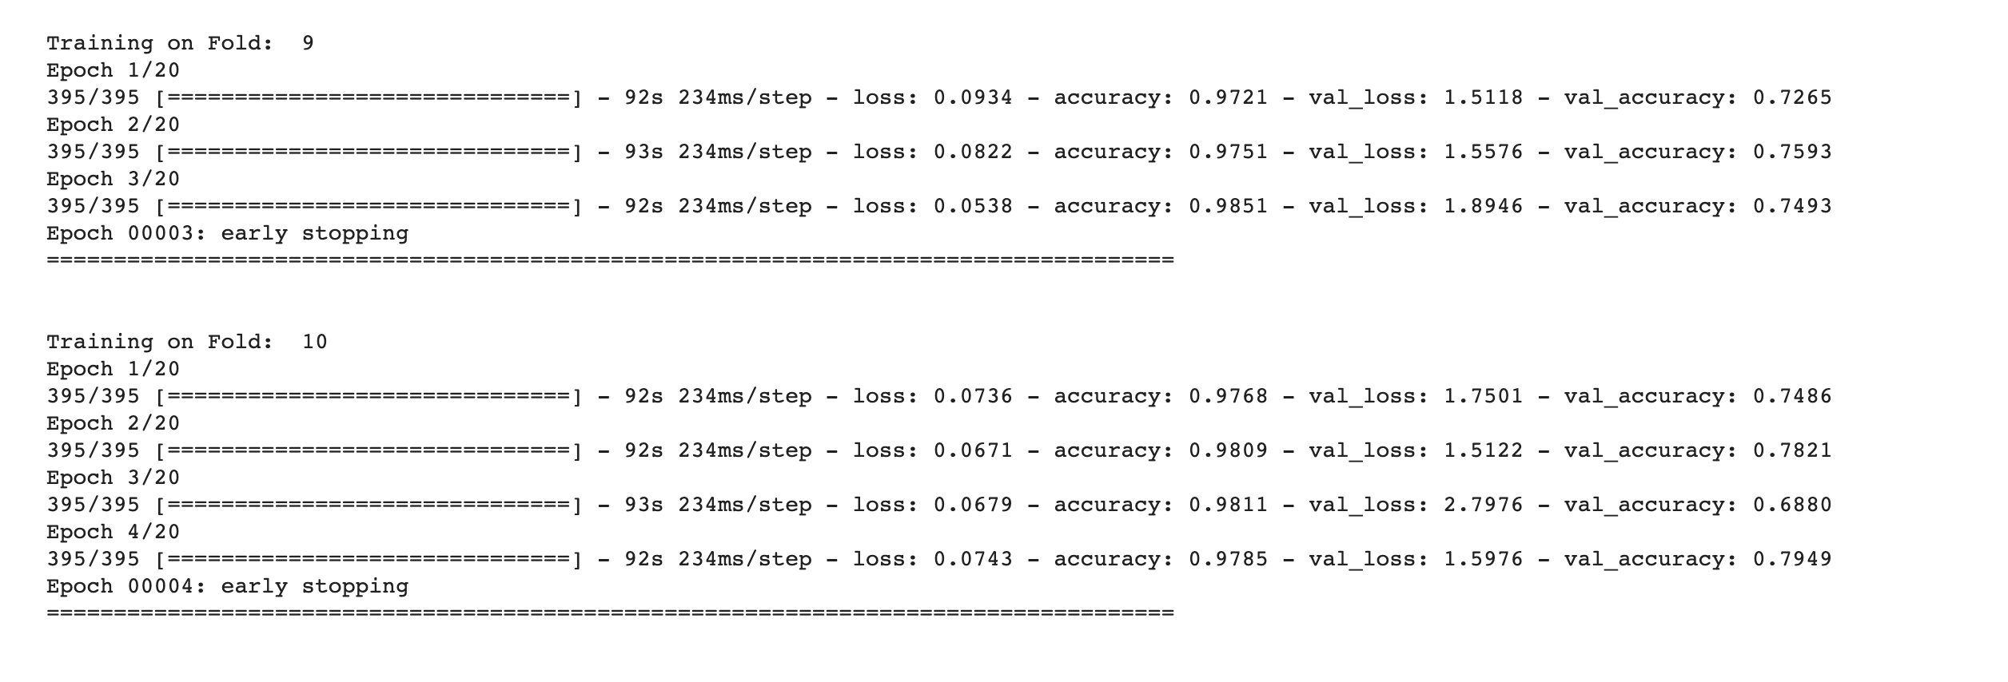

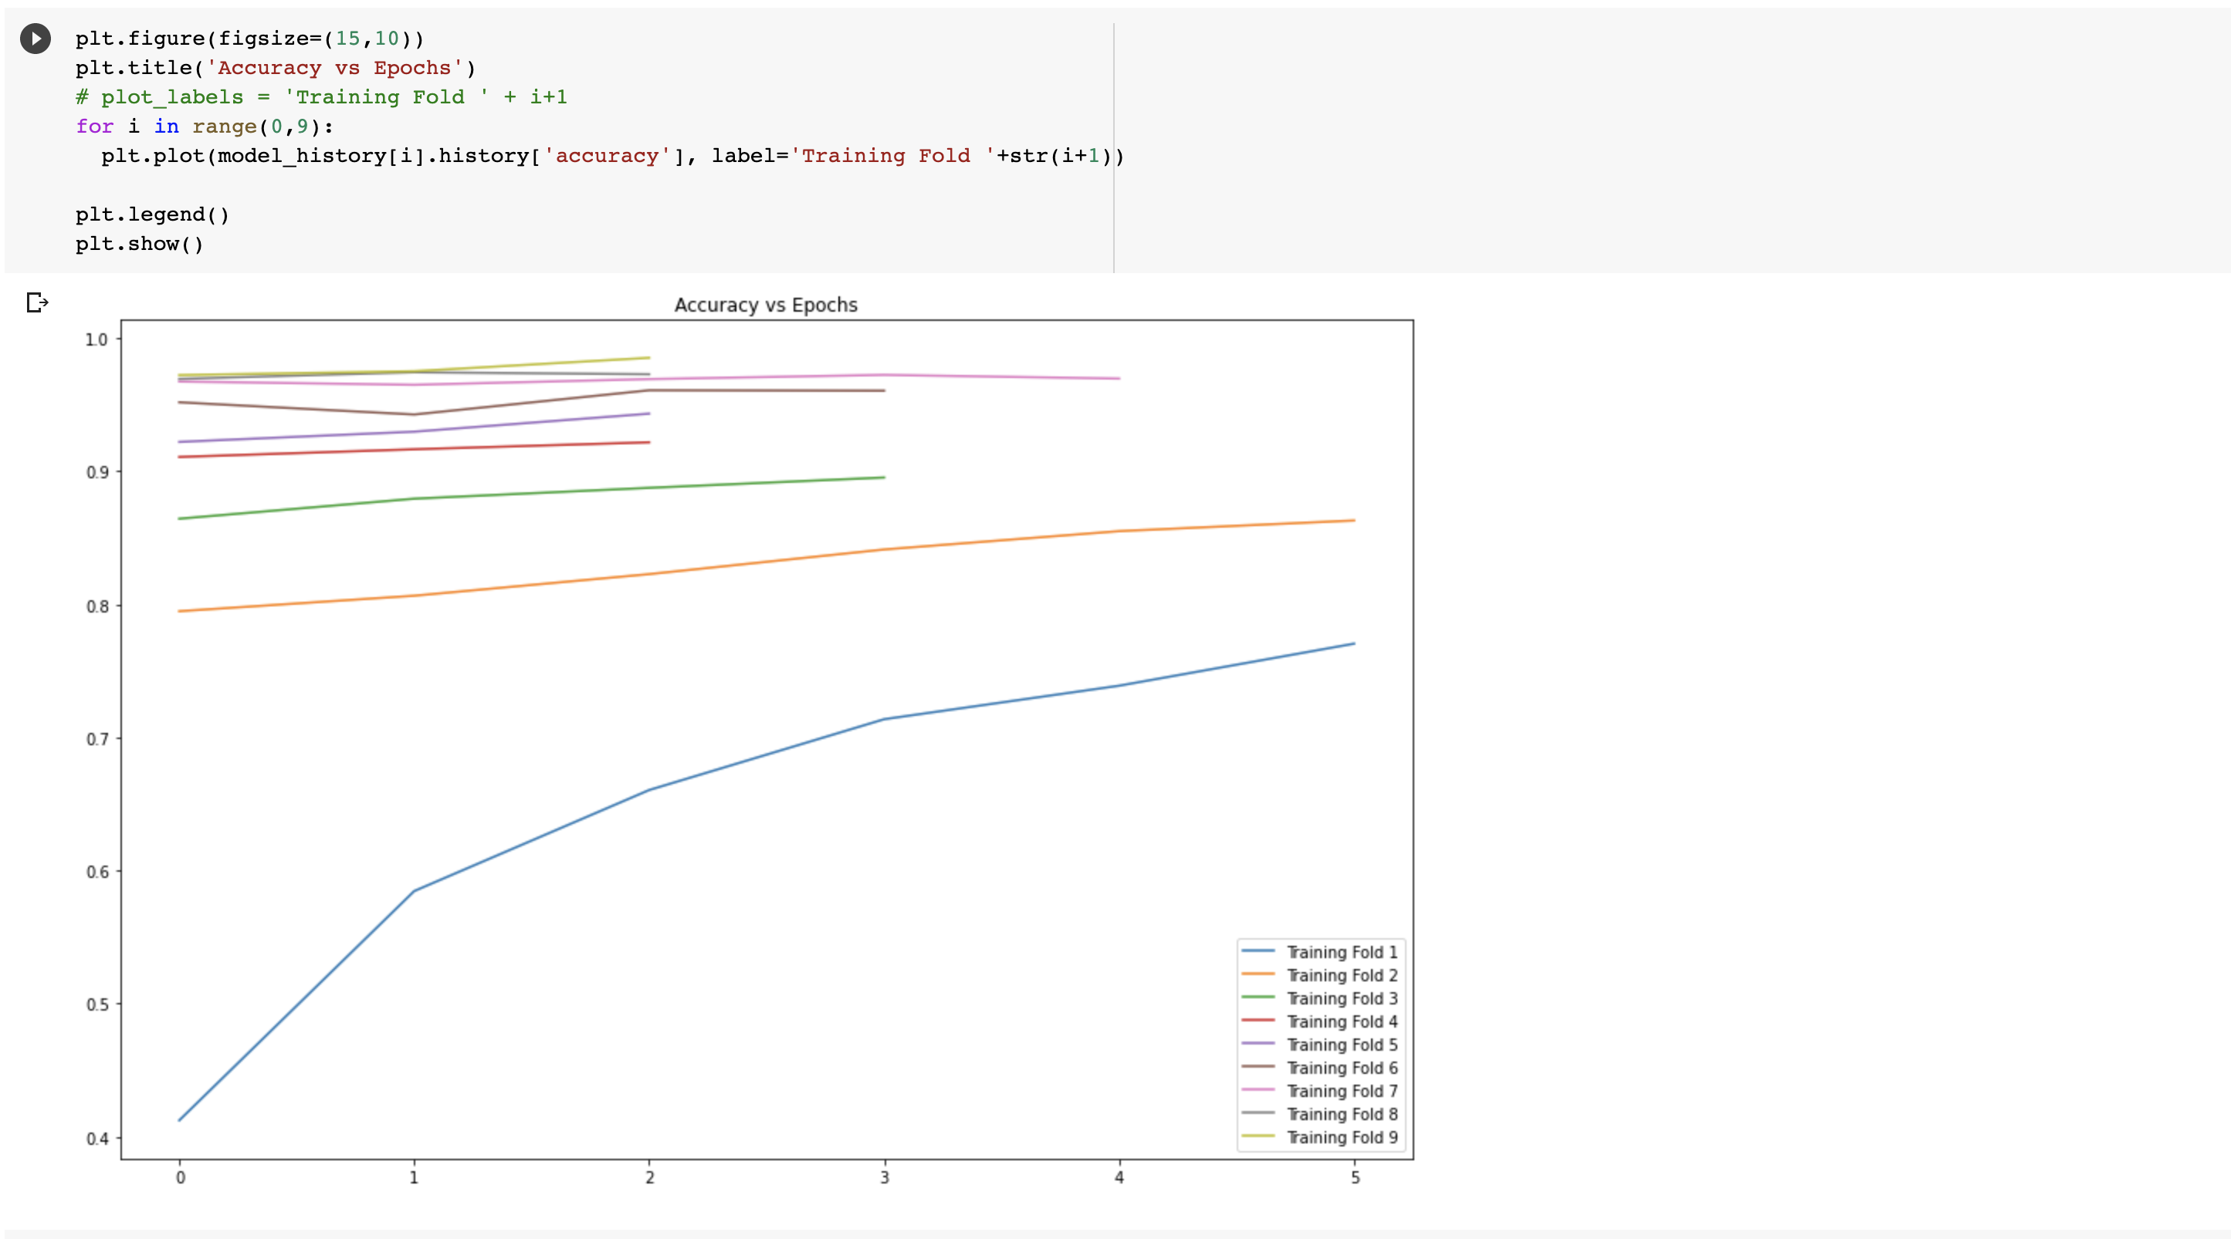

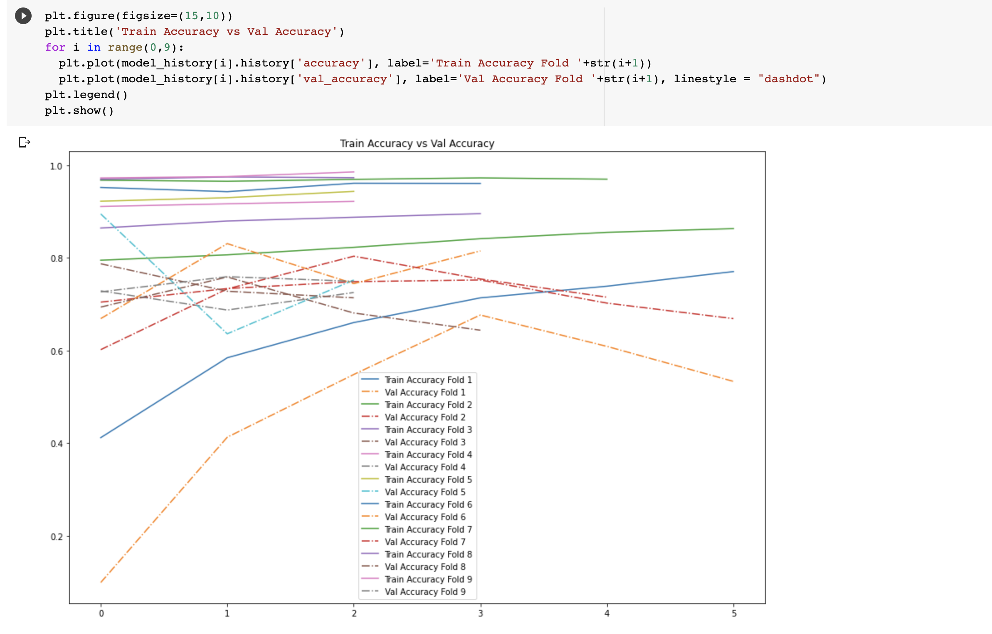

1. **Validation with test data**

The images and its categories from the test data are read test data set. These images are used to evaluate the model

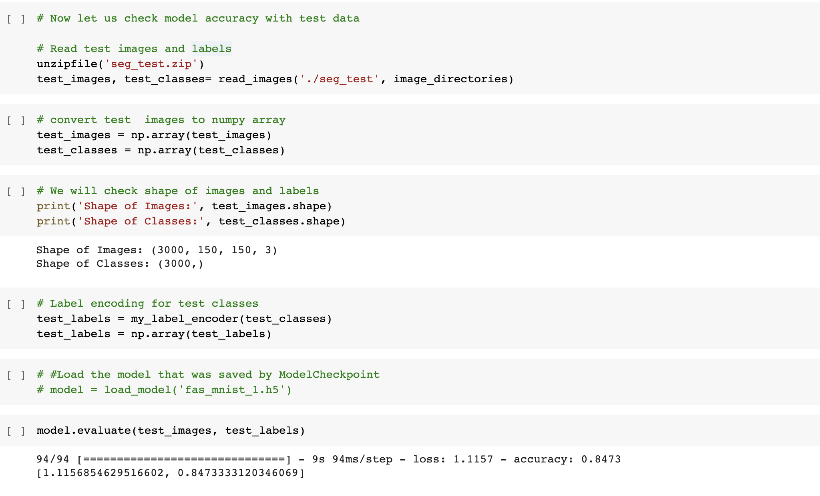

As we can see from the above result our model is 84% accurate with the test data.

1. **Predicting the labels for new images**

In this section our model is used to predict the categories of unknown images in the prediction data set. Prediction images and their labels are used from prediction data set. These prediction images are given to the CNN model one by one so that its category would be predicted. These predicted images are visualized as below.

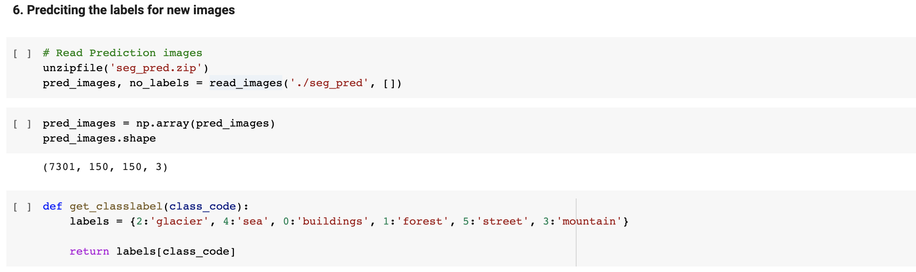

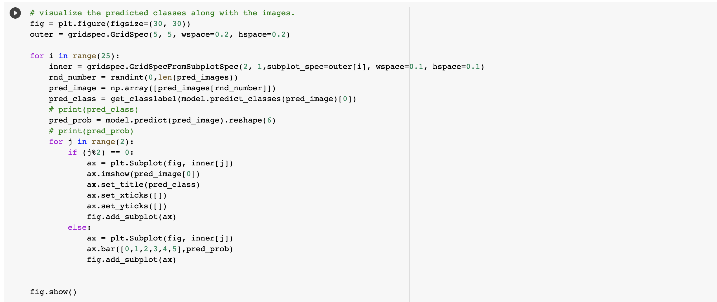

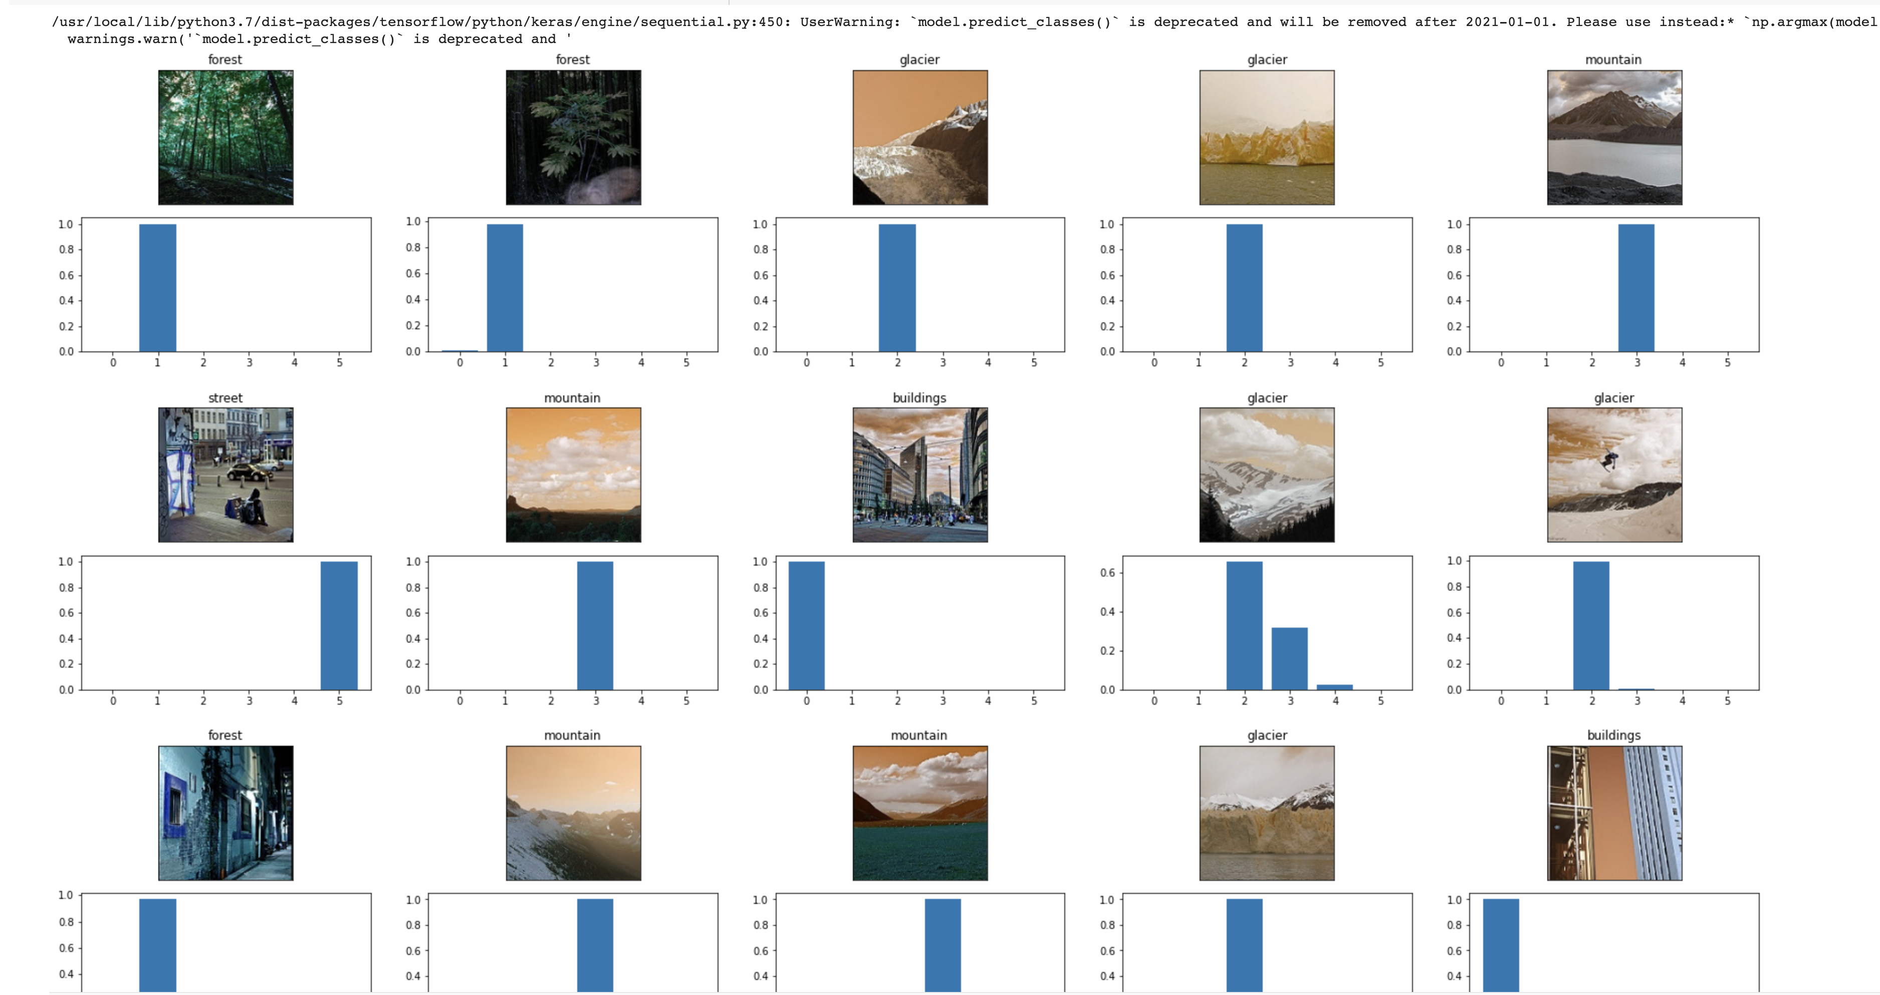

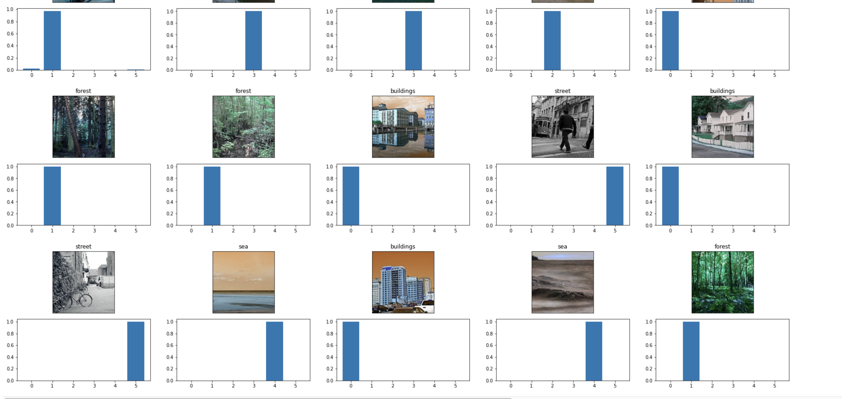

1. **Confusion matrix of the model**

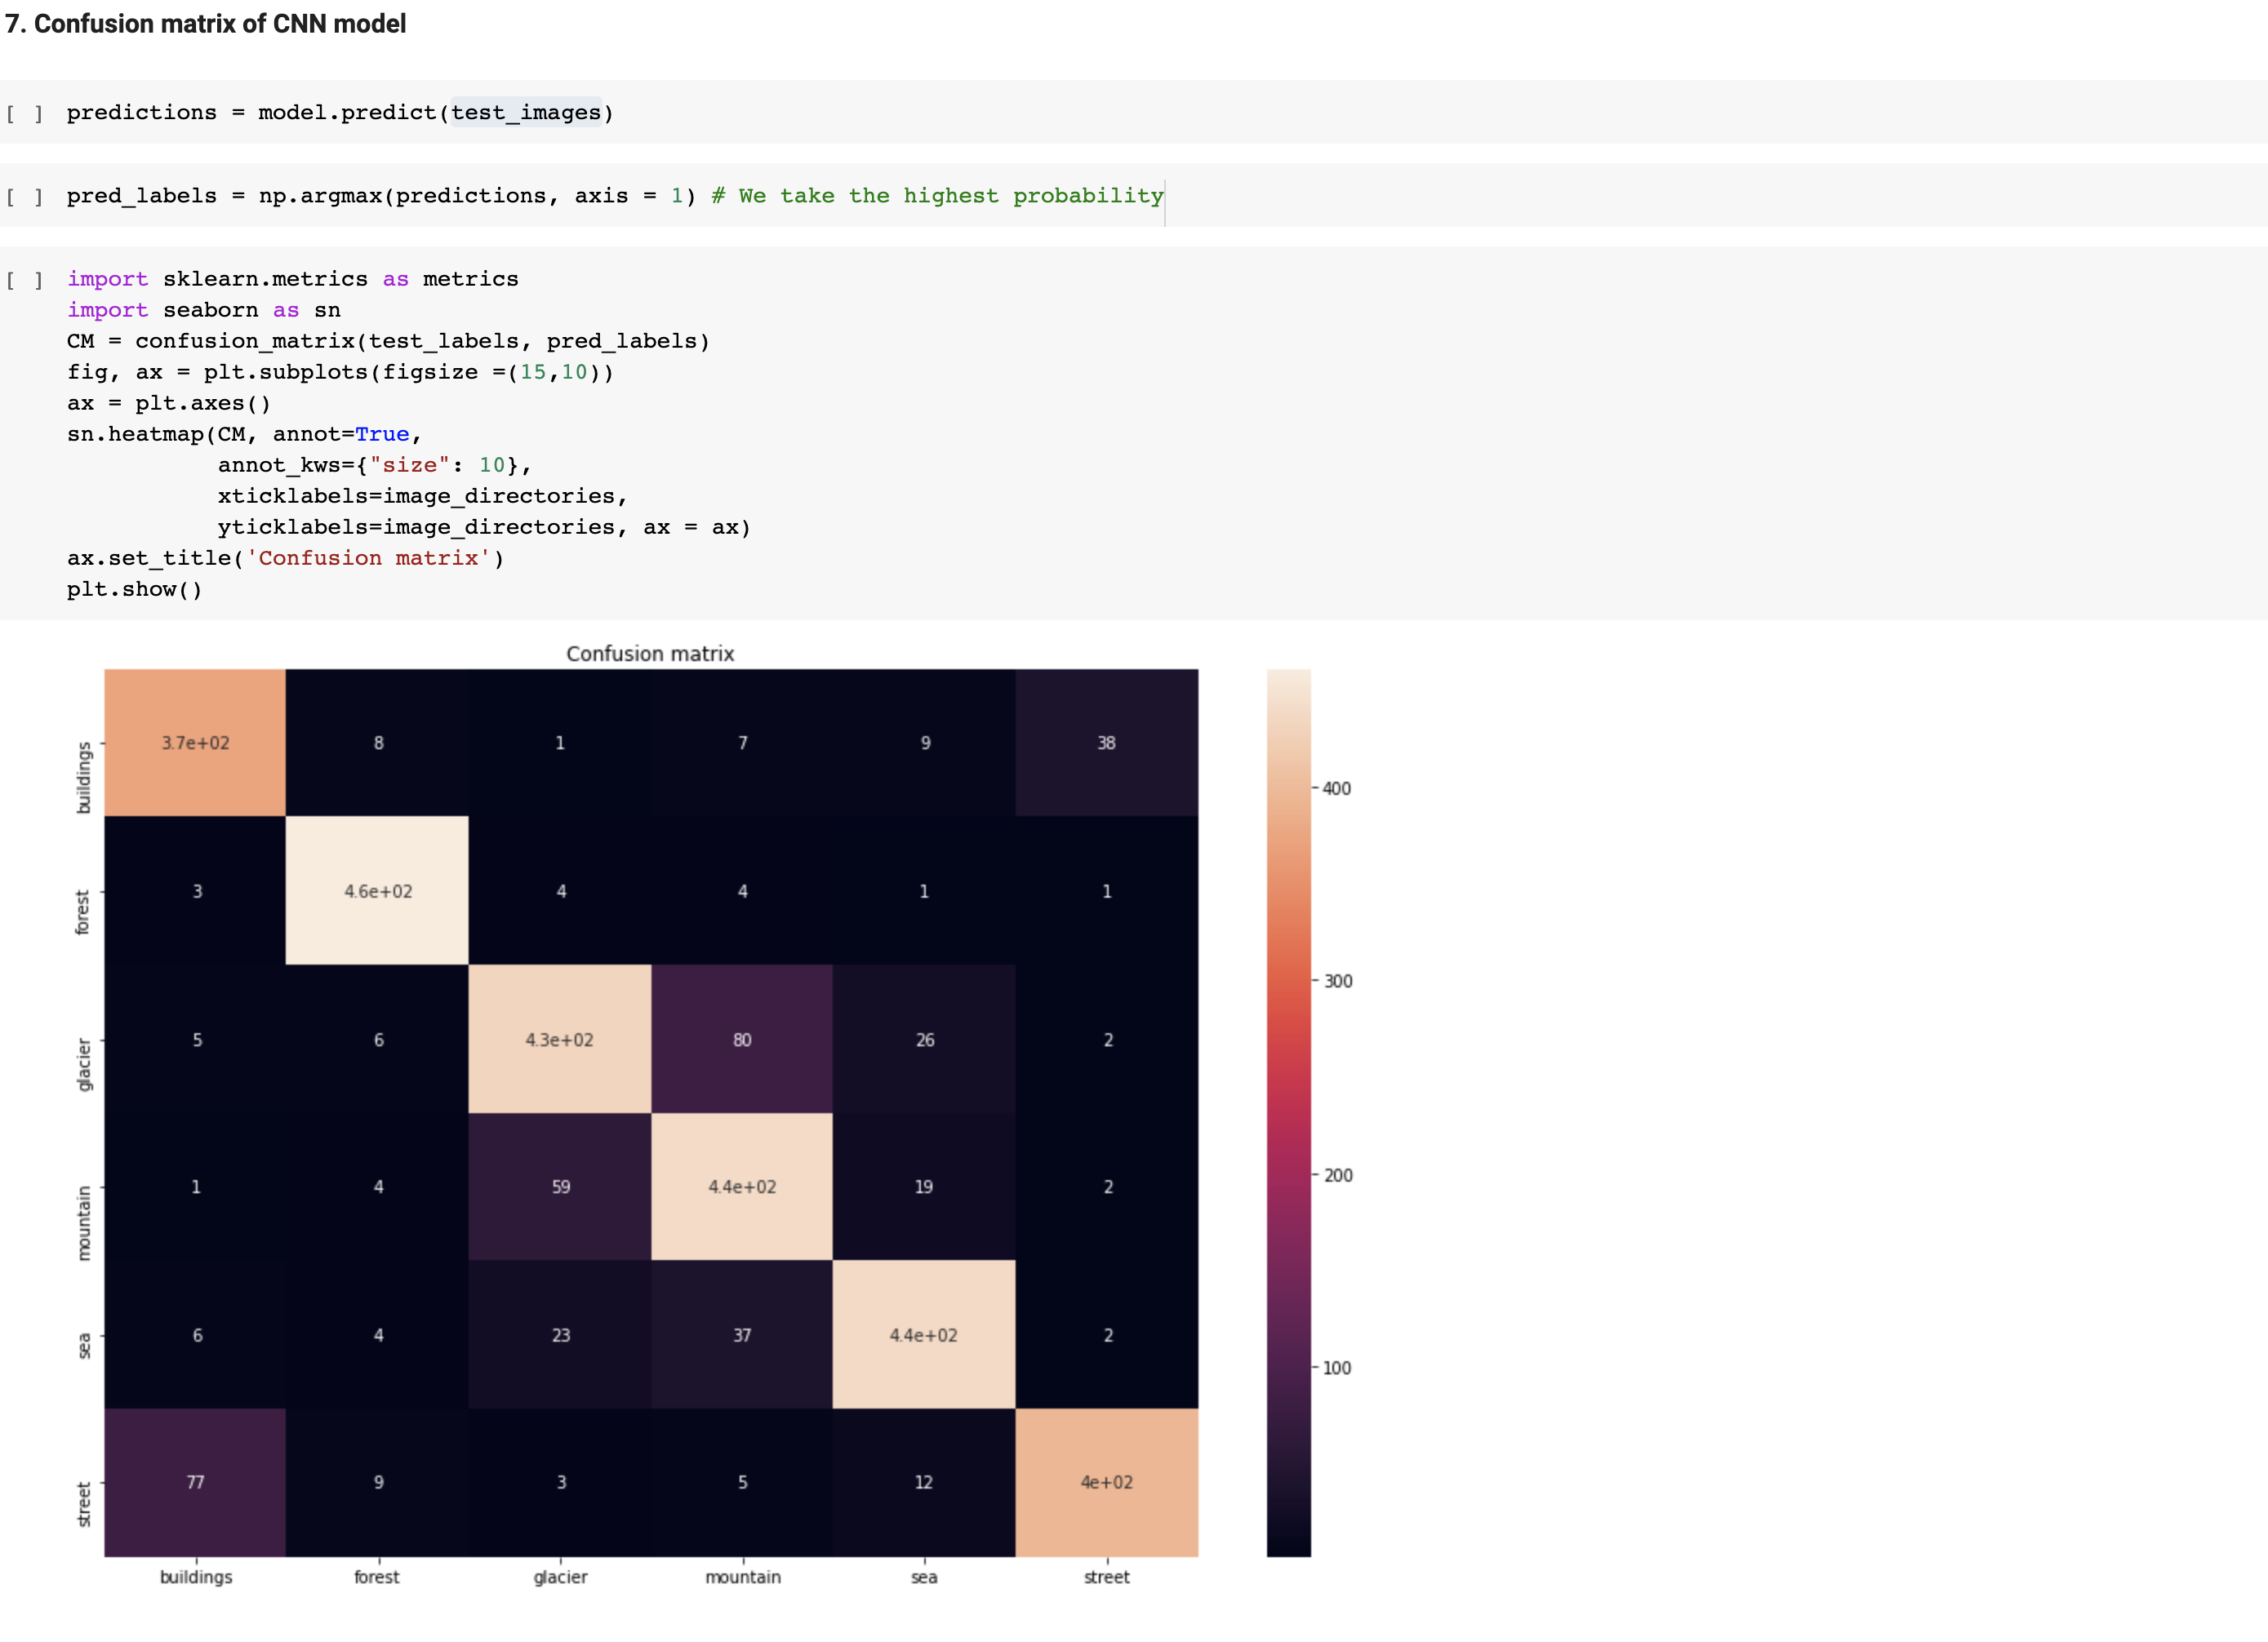

In the above confusion matrix, the diagonal elements represent the number of image categories predicted correctly for the test data.

1. **Transfer Learning:**

In this section a model using Transfer learning process. VGG (visual Graphic group) is used as model processor.

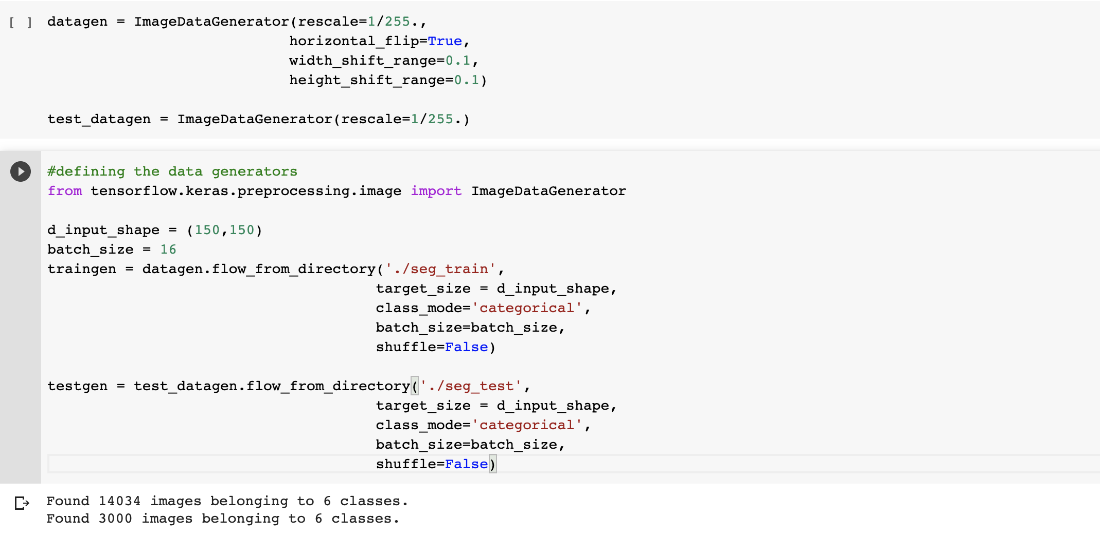

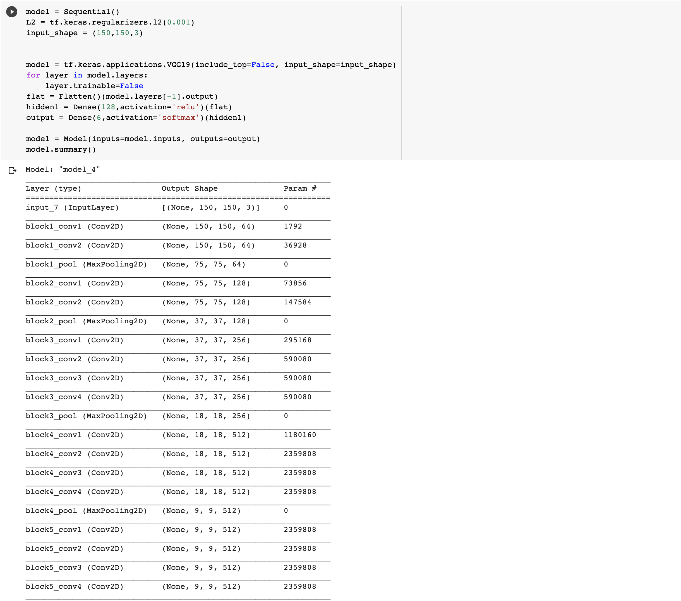

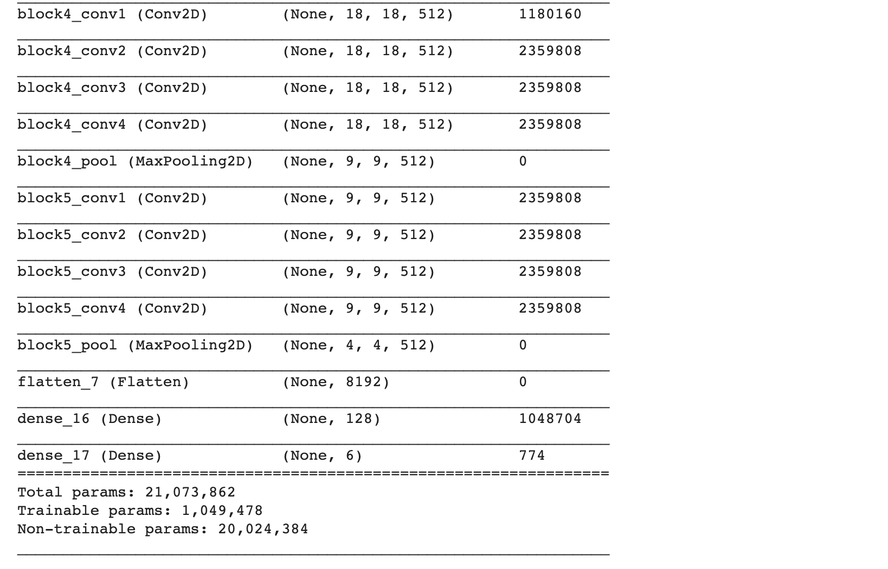

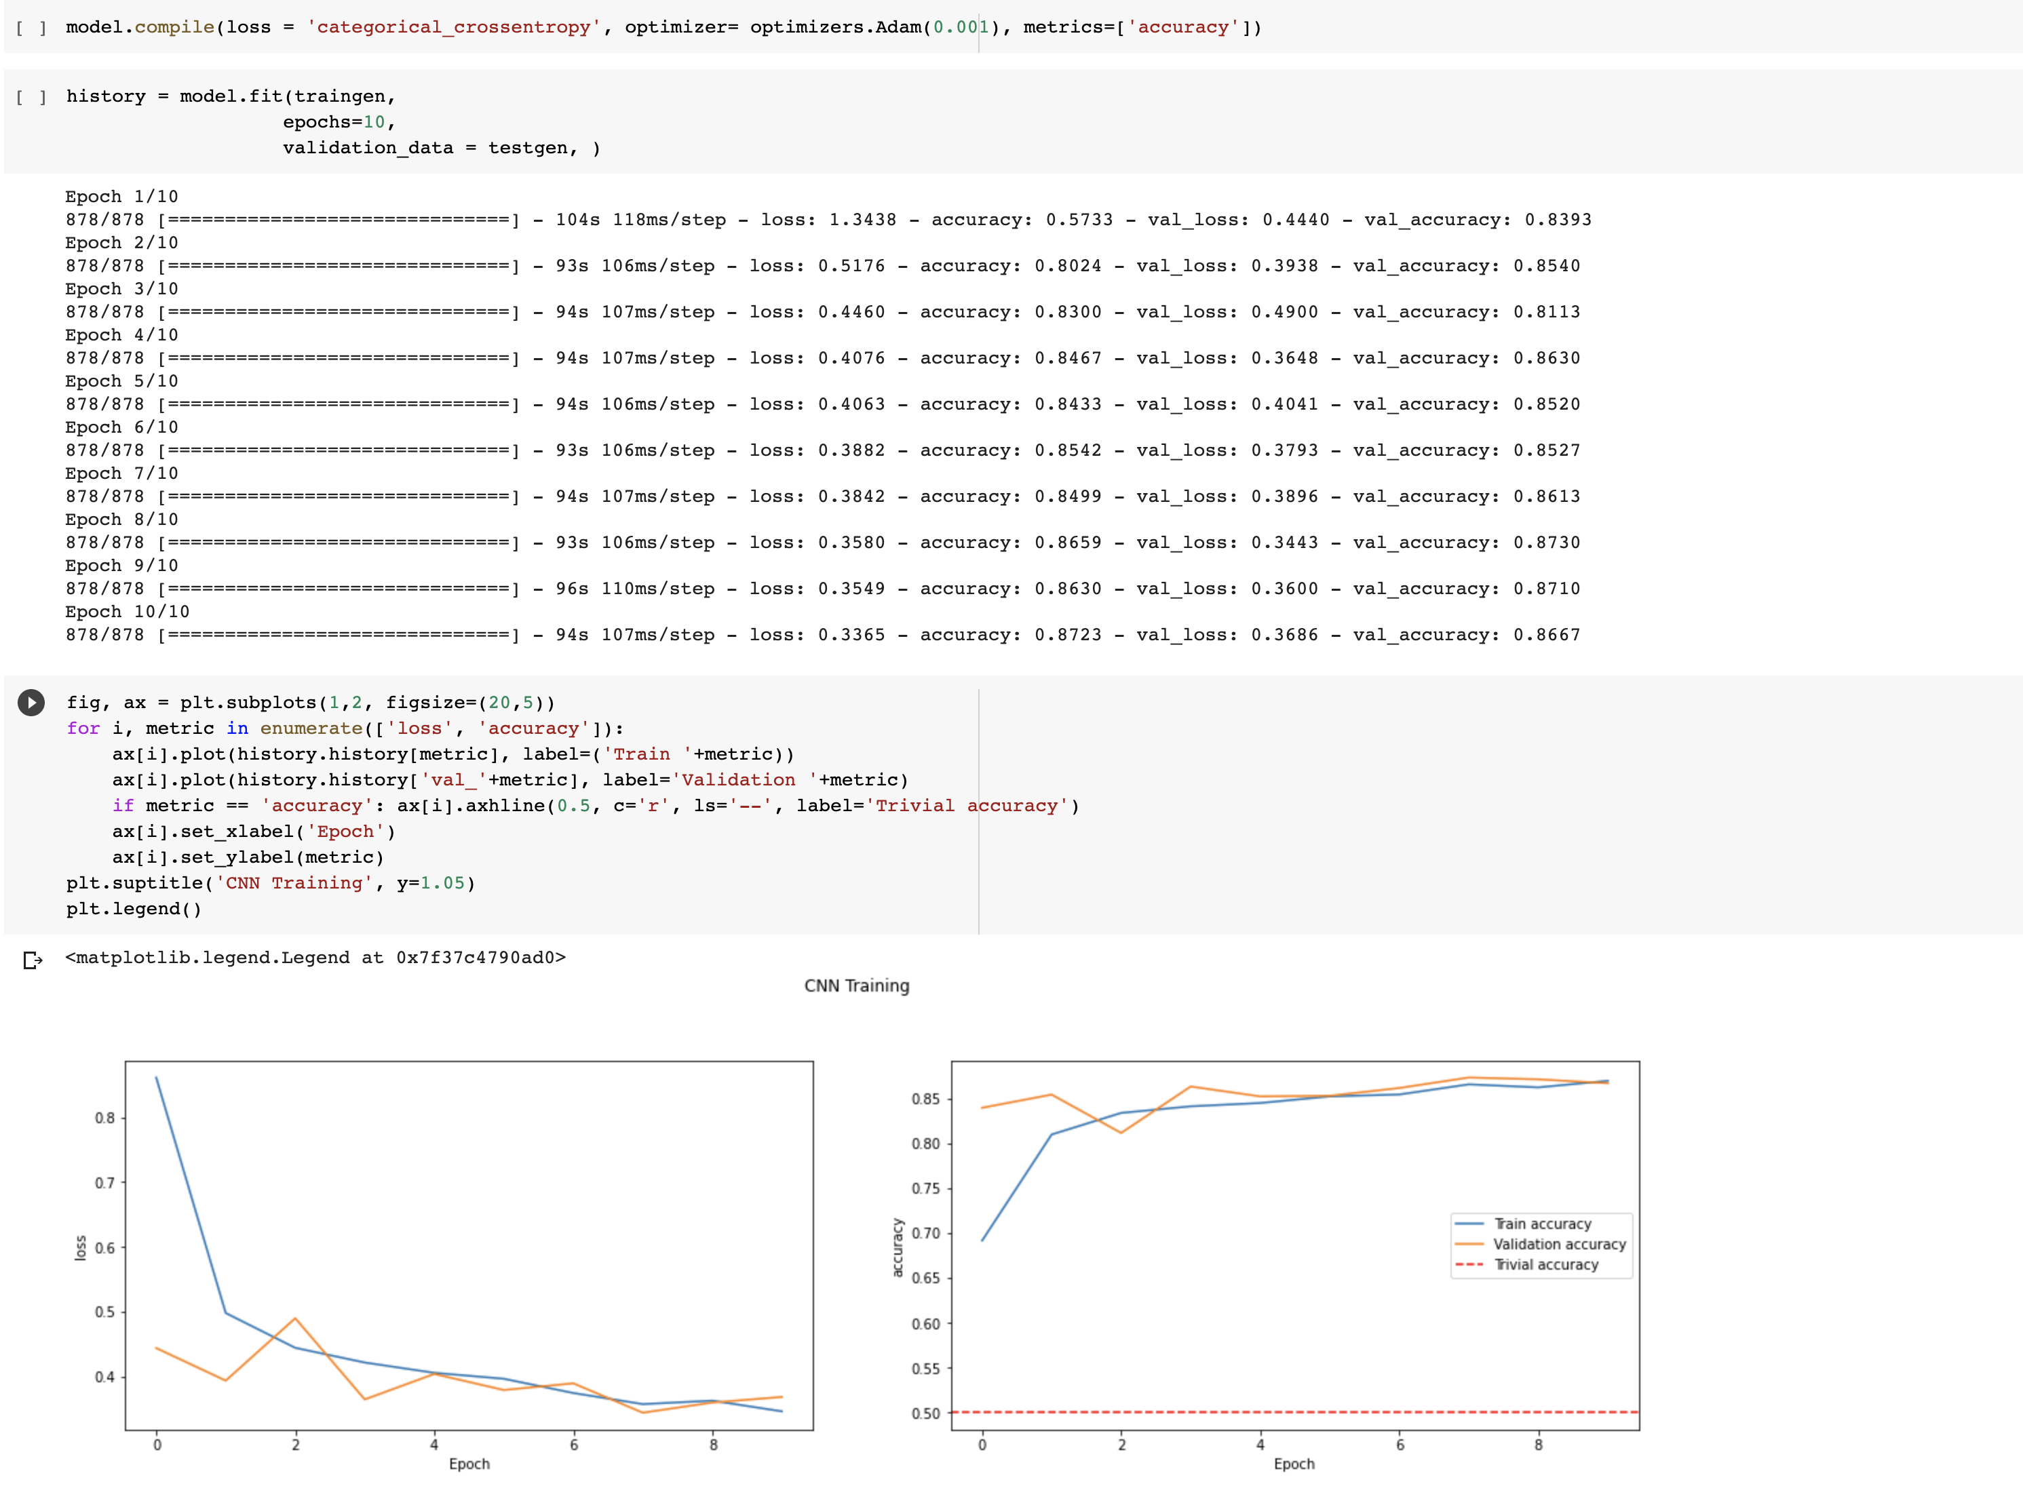

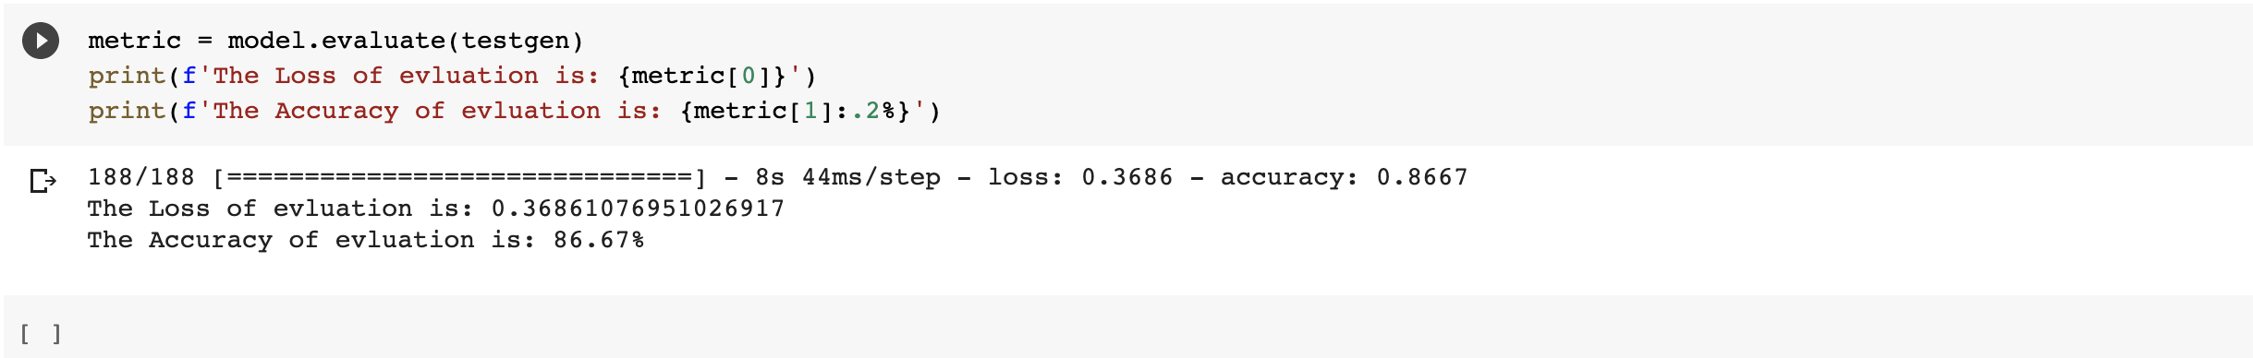

**Conclusion:** The two models CNN, Transfer learning model have almost same accuracy. Both can predict the image categories up to 86% correct.